**-ANALYSING HOUSING PRICES IN METROPOLITAN AREAS OF INDIA**

**INTRODUCTION :**

**Overview :**

**House price prediction in a metropolitan city in India is a valuable solution for potential home buyers, real estate agents, and investors. By leveraging historical sales data, property details, and location-specific information, a predictive model can accurately estimate house prices. The model's scalability, real-time updates, user-friendly interface, and transparency ensure it meets the needs of stakeholders. Integration capability, data privacy, and cost-effectiveness are also important considerations. By addressing these requirements, the prediction model provides reliable insights, empowering stakeholders to make informed decisions in the fast-paced real estate market.**

**Purpose :**

**House price prediction in a metropolitan city in India is a valuable solution for potential home buyers, real estate agents, and investors. By leveraging historical sales data, property details, and location-specific information, a predictive model can accurately estimate house prices.**

**Problem Definition & Design Thinking :**

Empathy Map : 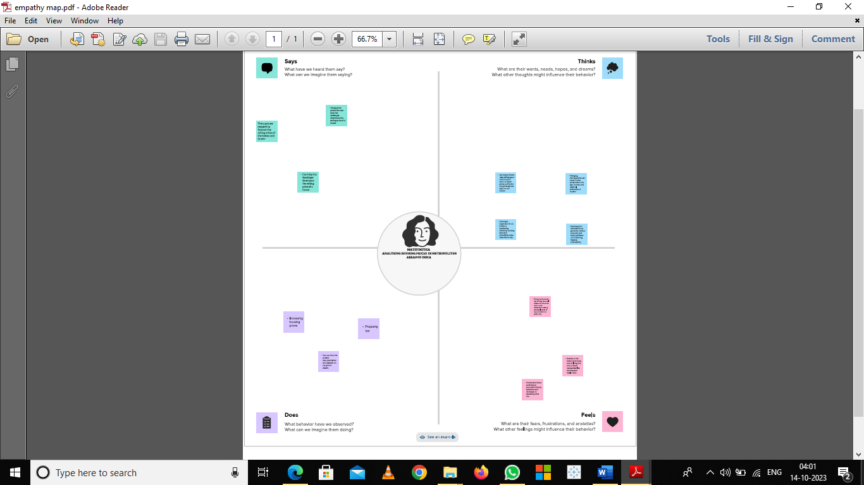

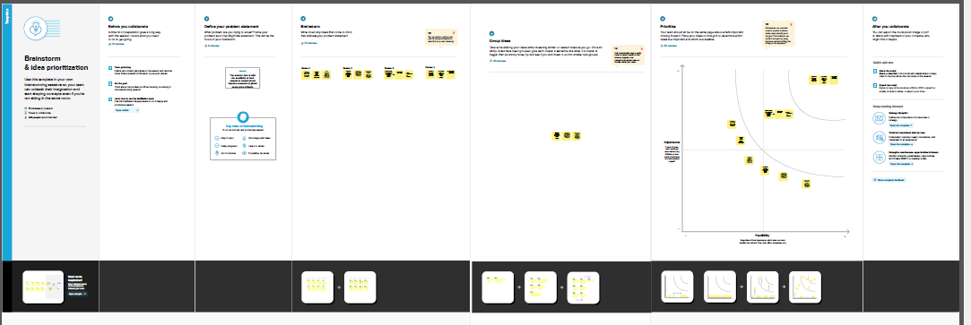

RESULT :

The estimated models using **city**-level data for India suggest a strong influence of fundamental factors in driving housing prices. There is compelling evidence of the effectiveness of macroprudential tools viz., Loan-

to-value (LTV) ratio, risk weights, and provisioning requirements, in influencing housing price movements.

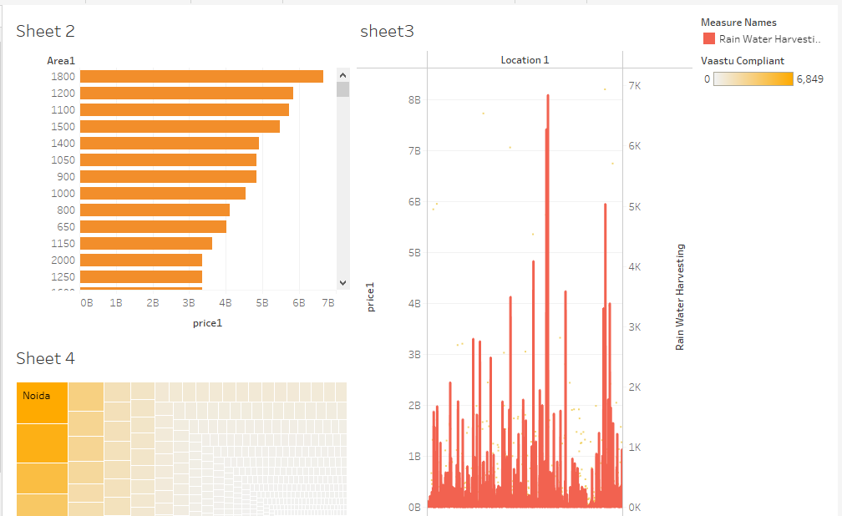

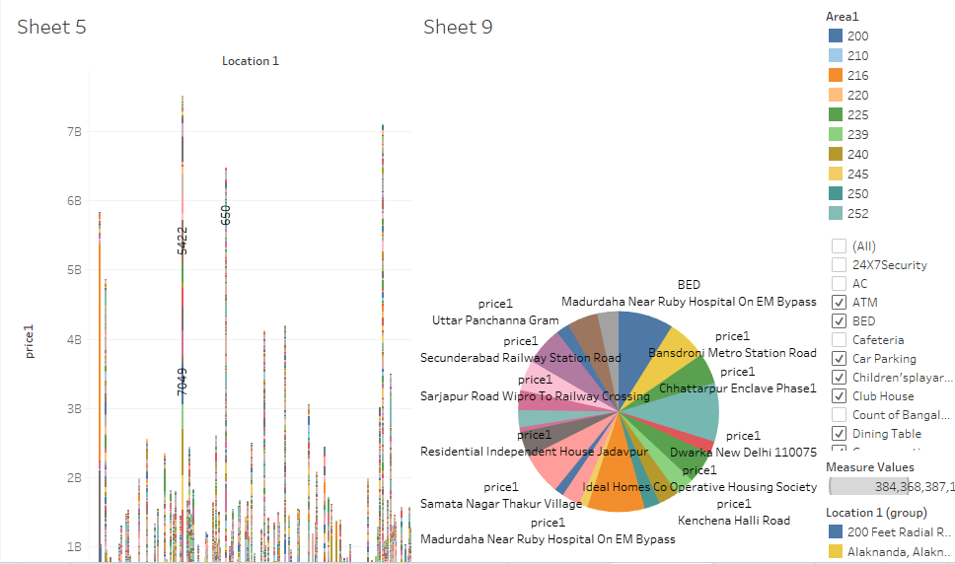

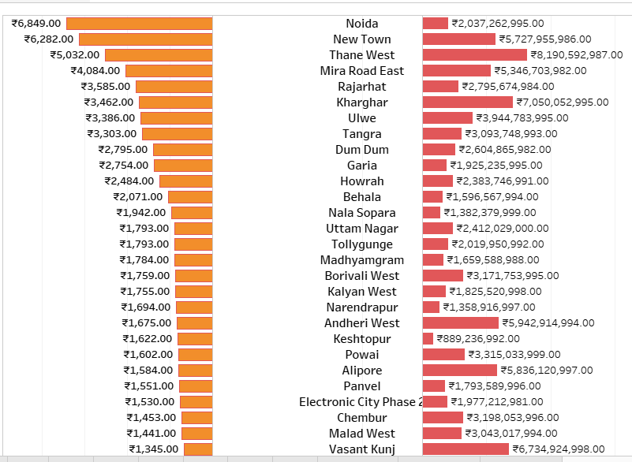

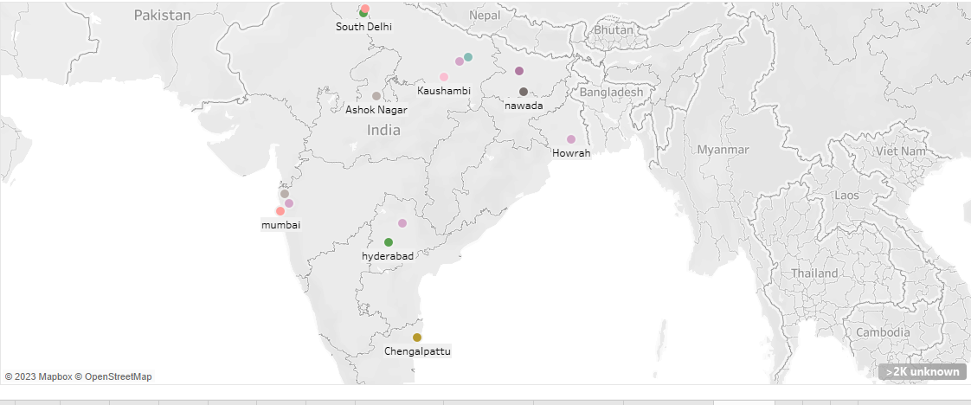

ADVANTAGES & DTSADVANTAGES :

* 1. NCT of Delhi India has one of the fastest-growing population rates in the world and a retail presence that is boosting promptly. ...
* 2. Mumbai You don’t live in Mumbai, and you strive, every day 24x7x365. ...
* 3. Bangalore Bangalore is the capital of Karnataka, an Indian state Located on the Deccan Plateau. ...
* 4. Chennai ...
* 5. Kolkata ...
* Adequate water supply,
* Assured electricity supply,
* Sanitation, including solid waste management,
* Efficient urban mobility and public transport,
* Affordable housing, especially for the poor,

APPLICATIONS :

House price prediction in a metropolitan city in India is a valuable solution for potential home buyers, real estate agents, and investors. [By leveraging historical sales data, property details, and location-specific information, a predictive model can accurately estimate house prices 1](https://nm.smartinternz.com/saas-guided-project/3/analysing-housing-prices-in-metropolitan-areas-of-india). [You can find datasets on Kaggle that contain prices of new and resale houses in metropolitan areas of India 2](https://www.kaggle.com/datasets/ruchi798/housing-prices-in-metropolitan-areas-of-india). [You can also check out MagicBricks for residential and commercial property price trends for localities in 16 cities across India 3](https://www.magicbricks.com/Property-Rates-Trends). [Additionally, you can find data on the Housing Price Index of India and Major Cities on the Open Government Data (OGD) Platform India 4](https://data.gov.in/catalog/housing-price-index-india).

CONCLUSION :

Through the data analysis and test in this paper, it can be summarized that the **multiple linear regression model** can effectively predict and analyze the housing price to some extent, while the algorithm can still be improved through more advanced machine learning methods.

FUTURE SCOPE :

The future of the real estate market in India is expected to be promising. [According to a report by **Livemint**, the residential real estate market in India had astounding progress in 2022, setting new sales records of 68% YoY, further demonstrating the industry’s prominence as one of India’s fastest-growing industries](https://www.livemint.com/money/personal-finance/future-of-real-estate-market-in-india-in-2023-11676368024008.html)[1](https://www.livemint.com/money/personal-finance/future-of-real-estate-market-in-india-in-2023-11676368024008.html)